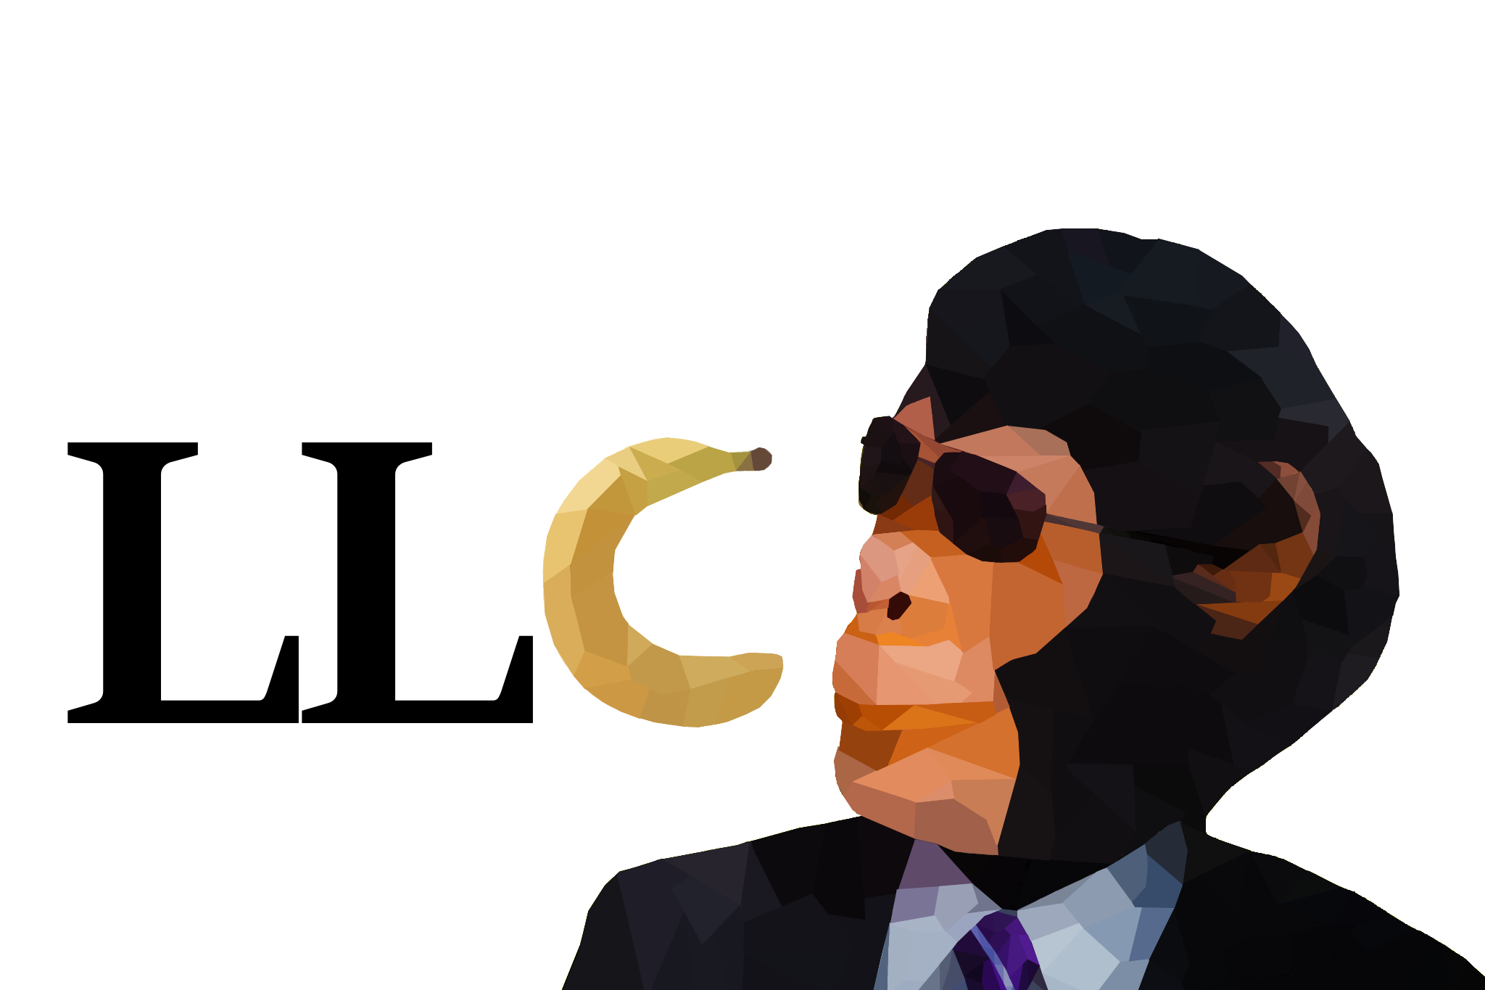

**Monkey Business LLC**

Banana Tactics

Request for Proposal  
Version 1.0

Document History

|  |  |  |  |
| --- | --- | --- | --- |
| Version | When | Who | What |
| 1.0 | 9/12/2023 | Caleb Mouat  Claire Westby  Shashwot Niraula  Gibson Moseley  Brent Knopp  Ben Murray  Damien Miller | Banana Tactics  Request For Proposal |

Table of Contents

1. Problem description
2. Project Objectives
3. Current System(s) – if any or similar systems
4. Intended users and their interaction with the system
5. Known interactions with other systems inside/outside the client organization
6. Known constraints to development
7. Project Schedule
8. How to Submit Proposals
9. Dates
10. Glossary of terms

1.0 Problem description / opportunity / expression of need

Monkey Business LLC faces the challenge of entering a market that already has several competitors with established products. However, there is great potential for growth in the video game market. The global gaming market size was valued at $249.55 billion in 2022 and is anticipated to grow from $281.77 billion in 2023 to $665.77 billion by 2030. Our initial success is pivotal not only for our company's reputation moving forward, but to capture this increased market share and exploit the lack of viable games in the Tactical RPG genre.

The unique genre fulfills an unserved niche. Tactical RPG genre presents a significant opportunity for us due to its limited competition in the current gaming landscape. Despite the recent surge in popularity of Tactical RPGs, most AAA studios have not ventured into this genre, leaving a void that we aim to fill. Additionally, while Nintendo's Fire Emblem series has been successful, it remains exclusive to their consoles, limiting accessibility for gamers on other platforms. This has created an underserved market of gamers interested in Tactical RPGs, but who lack the consoles produced by Nintendo.

Our first game in this genre is strategically vital. It not only introduces our company to the gaming community but also taps into a growing consumer base among gamers on non-Nintendo consoles.

2.0 Project Objectives

The objective of this project is to make a fun turn-based tactics game. This will be a game with multiple levels that players will be able to progress through and provide a fun but challenging experience. We will have a variety of unit classes, weapons, abilities, and attacks. The goal is to captivate the audience with a unique experience that has been lacking in typical Tactical RPG games.

This game should have:

* + **Level Grid**
    - Should function like a chess board and allow units to move around on them
    - Should have tiles that create environments
  + **Units**
    - Should have multiple types of units/classes that should have special features
    - Should have health
    - Should Have movement speed
    - Should have crit chance and miss chance
    - Should have special movement depending on class
    - Should be stronger with different weapons
  + **Tiles/Environment**
    - Multiple different terrain types that limit certain units' movement.
    - Have events/interactable objects and places on those tiles.
      * Like a well that gives the unit on the tile +3 health etc.
  + **Combat**
    - Have unique attacks that do different damage
    - Have some attacks that have range
    - Have unique animations
  + **Enemy and Enemy AI**
    - Enemy units should move themselves
    - Use multiple parameters
  + **Interactable/Events**
    - Board-wide events to shuffle up gameplay.
    - Interactable that are not tile based but can have similar function
  + **Inventory**
    - Each unit has their own inventory system that tracks what items they have
  + **Menu/UI**
    - Have a map system that allows players to move through levels (an overworld screen)
    - Pause Screen
    - Menu
    - When you over any unit it should show health and if your unit their inventory
    - Have combat UI that allows you to see the chance of hit/crit and predicted damage.
  + **Dr. BC Mode**
    - Your units can't die, and all enemy units are one shot
  + **Save/Load Function**
    - Saves the progress of the player to be loaded at another time

3.0 Current system(s) – if any / similar systems

Our current competitors in the Tactical RPG genre include well-established series by AAA developers, such as Fire Emblem and Advanced Wars by Intelligent Systems, as well as the XCOM series by Firaxis Games. Additionally, we face competition from various one-off Tactical RPGs produced by Square Enix. Notably, none of these series has seen a new release on Xbox or PC platforms in the past two years.

Given this context, our strategic intent is to cater to the existing market of gamers who are interested in Tactical RPGs, particularly on PC and Xbox. Our upcoming game will draw heavy inspiration from the single-unit, character-focused gameplay, and engaging storytelling seen in games like Fire Emblem. By doing so, we aim to provide a fresh and enticing experience to enthusiasts of the genre who have been awaiting new releases on these platforms.

Fire Emblem Series:

* + **One of the most popular and bestselling game series in the Tactical RPG genre**
  + **Gameplay Features:**
    - Turn-Based: Players take turns taking all their actions with each individual player unit before handing control over to a computer AI to move its units. Turns only end when all units for one side have taken an action, or the player/computer ends their turn early.
    - Permanent Death: once a player unit dies, they are permanently removed from the game, adding a layer of consequence and strategy.
    - Weapon Triangle System: Comparable to rock paper scissors; units can gain an advantage over enemies by having a weapon equipped that the enemy is weak to, and conversely be at a disadvantage if they are weak to the enemy’s weapon.
    - Limited Durability Weapons: Weapons have limited durability in the game before they break and are unusable, requiring players to manage their resources and make strategic decisions on when and where to use their strongest weapons.
    - Customizable inventories: Players will have the ability to customize inventories and trade items between units, giving them control over their party's gear and resources.
    - Unique Skills for Player Units: Players are given access to items that grant additional effects to individual units (such as healing the player unit when they attack or giving the player unit an extra strong attack.)
    - Support System: One of the most popular features of the Fire Emblem series is the "support" system that allows player units to strengthen their bonds and gain advantages when fighting alongside specific allies. It also provides additional narrative depth to the story with unique interactions and dialogue between player characters.

4.0 Intended users and their basic interaction with the system

**Users**

* Casual and experienced gamers looking for an accessible and entertaining gaming experience.
* Gamers with an eye for strategy who enjoy planning and executing complex tactical maneuvers.
* Enthusiasts, advocates, and those who possess a deep appreciation of monkeys and other primate species.

**Uses**

* A keyboard and mouse for the user to control their unit(s) and otherwise interact with the game’s environment and menus.
* Strategically position and move units across the game grid during battles.
* Choose which attack type and/or weapon to use when engaging in combat.
* Explore the map terrain to uncover and collect resources, collectibles, weapons, and other bonuses and boons to aid them in battle while simultaneously avoiding dangerous tiles such as traps and dangerous terrain.
* Utilize terrain and environmental elements granted to them by their unit type to gain an advantage.

5.0 Known interactions with other systems within or outside of the client organization.

* + **Steam**
    - Steam could be used as one of the main distribution platforms, it will also be able to interact with our game through achievements, social networking and tracking.
  + **Apple app/Google play stores**
    - Much like Steam the Apple App Store and the Google Play Store could be used for distribution of our game. Unlike steam though these two do not offer achievements and social networking.
  + **Controller**
    - Our game should be able to be played via controller as well as mouse and keyboard. Meaning the player will be able to interact with our game with a controller in the case that they would prefer that over mouse and keyboard.

6.0 Known constraints to development

* + **Unity**
    - Unity is the main game engine for our game, so we are limited on exactly how much control we have over certain elements meaning certain complexity is impossible. This also means that c# will be used as the main programing language and knowledge of c# is necessary.
  + **Time**
    - The tight deadline for our project means, less time to for work meaning our projects scope must stay limited as to be completable within the deadline.
  + **Funding**
    - Due to the limited funding available for this project we are limited to using only free and/or opensource software, which could affect the maximum level of complexity achievable.

7.0 Project Schedule

|  |  |
| --- | --- |
| 09/17/23 | RFP |
| 09/19/23 | Group Meeting #4 – Plan Presentation |
| 09/21/23 | SA Presentation |
| 09/24/23 | Proposal Chosen |
| 09/28/23 | Minimum Viable Product |
| 10/08/23 | Group Meeting #5 – Code Development Check-in |
| 11/02/23 | Group Meeting #6 – Code Development Check-in |
| 11/12/23 | Individual Code Complete |
| 11/12/23 | Oral Exams |
| 11/19/23 | Group Meeting #7 – Final Code Edits |
| 12/03/23 | Group Meeting #8 – Final Code Edits |
| 12/07/23 | Group Code Complete |
| 12/07/23 | Final Demo |

|  |  |
| --- | --- |
| 8.0 | How To Submit Proposals |
|  | Regarding proposal submissions, our approach aims for efficiency and user-friendliness. Specifically, our submission method involves electronic submission via Git, implying that the proposals will be uploaded to the **Docs folder on GitHub**. |
| 9.0 | Dates |
|  | The deadline for submission is September 21st, 2023. The results will be notified by September 24th, 2023. |
| 10.0 Glossary of terms | |

**Turn-based:** A game where each player takes turns doing their actions and moves

**Tactics Game:** A strategic game where you move units to further a goal (like chess)

**Level Grid:** The board in which the units are placed on and what the player can interact with (like a chess board)

**Unit:** the moveable actors/things that are assigned tasks by the players like attacking

**AAA:** an informal classification used to categorise video games produced and distributed by a mid-sized or major publisher, which typically have higher development and marketing budgets than other tiers of games.

**Crit Chance:** a stat that denotes the probability, or chance, that a basic attack will critically strike.

**Miss Chance:** a stat that denotes the probability, or chance, that a basic attack will miss.

**UI:** (User Interface) is the point of human-computer interaction and communication in a device.